I set password last night this way. Then I was locked out of phpMyAdmin.

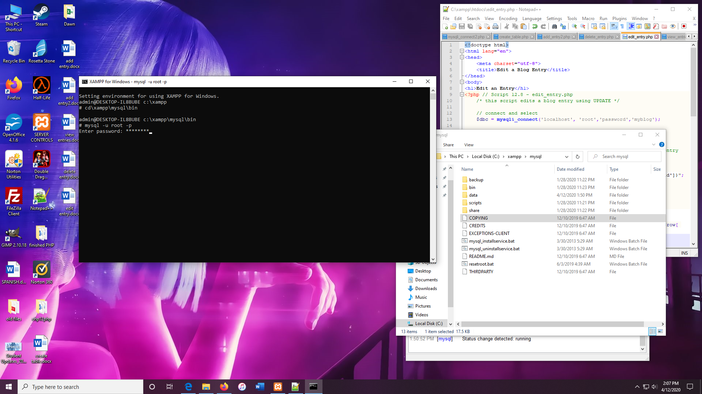

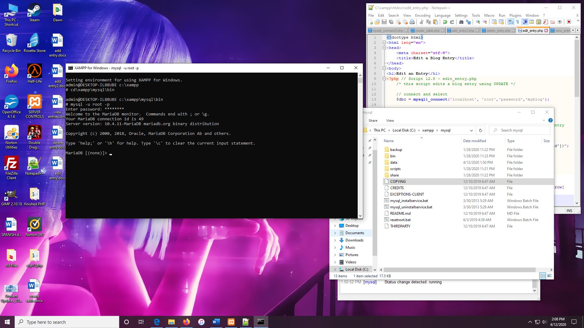

Found I had to go into **config.inc.php** file and change the password in that to get access.

Otherwise, we can do it this way as well.

